Follow the below link document steps to download and import Acadgild Spark VM in

the Oracle Virtual Box.

<https://drive.google.com/file/d/0ByJLBTmJojjzQ2hLc1RLX3pST0U/view>

Importing the file

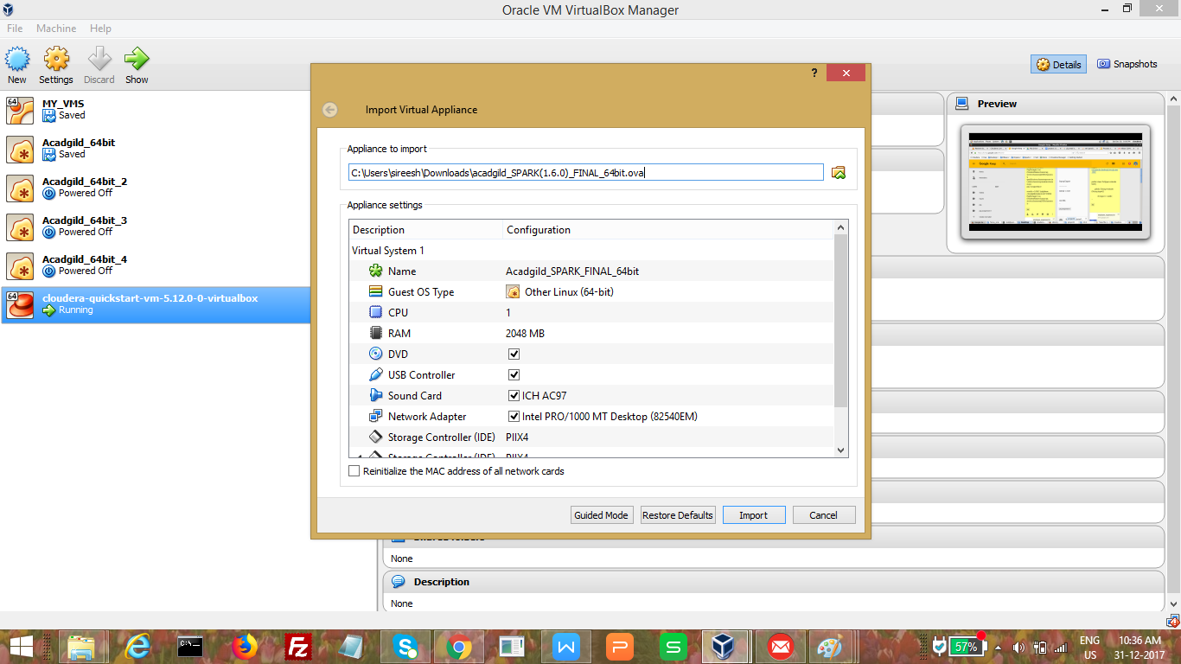

Importing spark ova file to acadgild vm

